**California State University, Northridge**

**College of Engineering & Computer Science**

**Electrical and Computer Engineering Department**

**ECE 443L Digital Electronics Laboratory Report 6**

**CMOS based Astable Multivibrator Circuit Design, Simulation and Experimental Test as well as Analysis**

**By Evan Thomas, Haroutun Haroutunian,**

**Clayton Lawton**



**Professor: Sequare Daniel-Berhe**

**Abstract:**

An astable multivibrator is a cross-coupled transistor with an astable output state as the input states transition from high to low. Main utilizations of astable multivibrators can be found in pulse position modulation and frequency modulation. The construction of such circuit is simple, as the most difficult part would be to calculate the input frequency and time constant.

**Key Terms:**

Astable, multivibrator, modulation, pulse, time constant (0.7*R*C)

**Simulation and Experimental Result:**

Figure 6.1: Case 1 CLAYTON Astable Multivibrator Schematic @ 100kHz

Figure 6.2: Case 1 CLAYTON Astable Multivibrator Waveform @ 100kHz

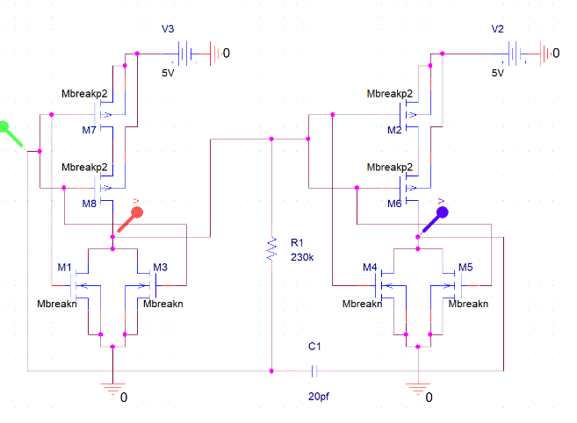

Figure 6.3: Case 1 EVAN Astable Multivibrator Schematic @ 111kHz

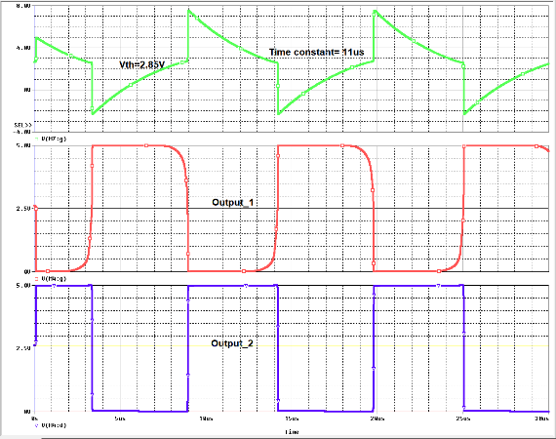

Figure 6.4: Case 1 EVAN Astable Multivibrator Waveform @ 111kHz

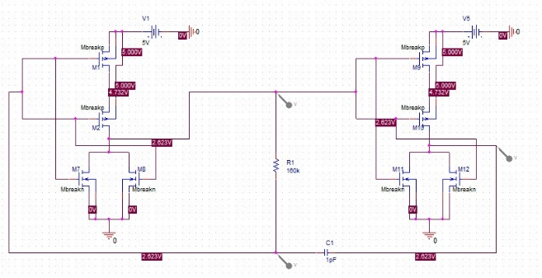

Figure 6.5: Case 2 HAROUTUN Astable Multivibrator Schematic @ 500kHz

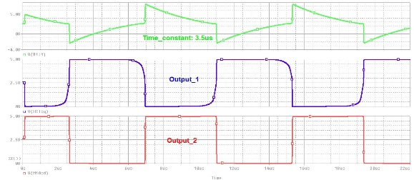

Figure 6.6: Case 2 HAROUTUN Astable Multivibrator Waveform @ 500kHz

Figure 6.7: Case 3 CLAYTON Astable Multivibrator Schematic @ 670kHz

Figure 6.8: Case 3 CLAYTON Astable Multivibrator Waveform @ 670kHz

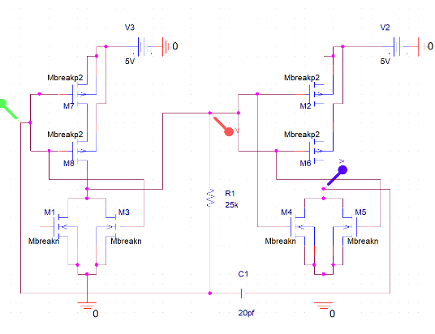

Figure 6.9: Case 3 EVAN Astable Multivibrator Schematic @ 800kHz

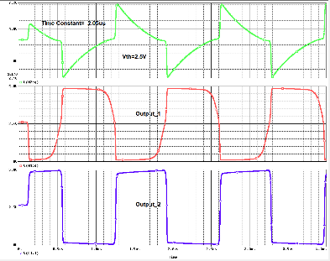

Figure 6.10: Case 3 EVAN Astable Multivibrator Waveform @ 800kHz

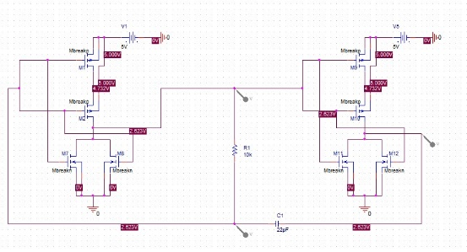

Figure 6.11: Case 4 HAROUTUN Astable Multivibrator Schematic @ 1Mhz

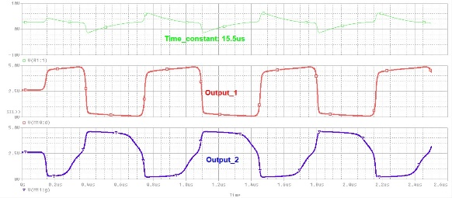

Figure 6.12: Case 4 HAROUTUN Astable Multivibrator Waveform @ 1Mhz

**Conclusion:**

Astable Multivibrators, although aren’t found in everyday electronics, are very useful within the medical field. Such circuits are utilized in heartbeat sensor machines and any modulation device. Pulse synchronization is a common area for such circuits.